Kubernetes Task
Task Description:
Setup minikube at your local and explore creating namespaces (Go through official documentation).

Install latest Docker desktop on local machine (pre-request):
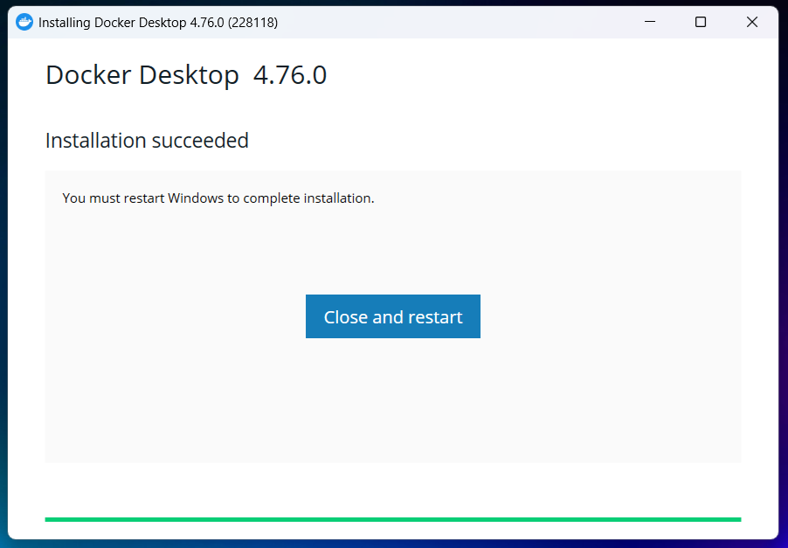
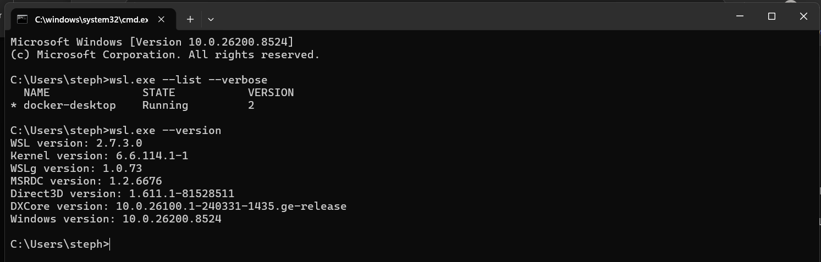
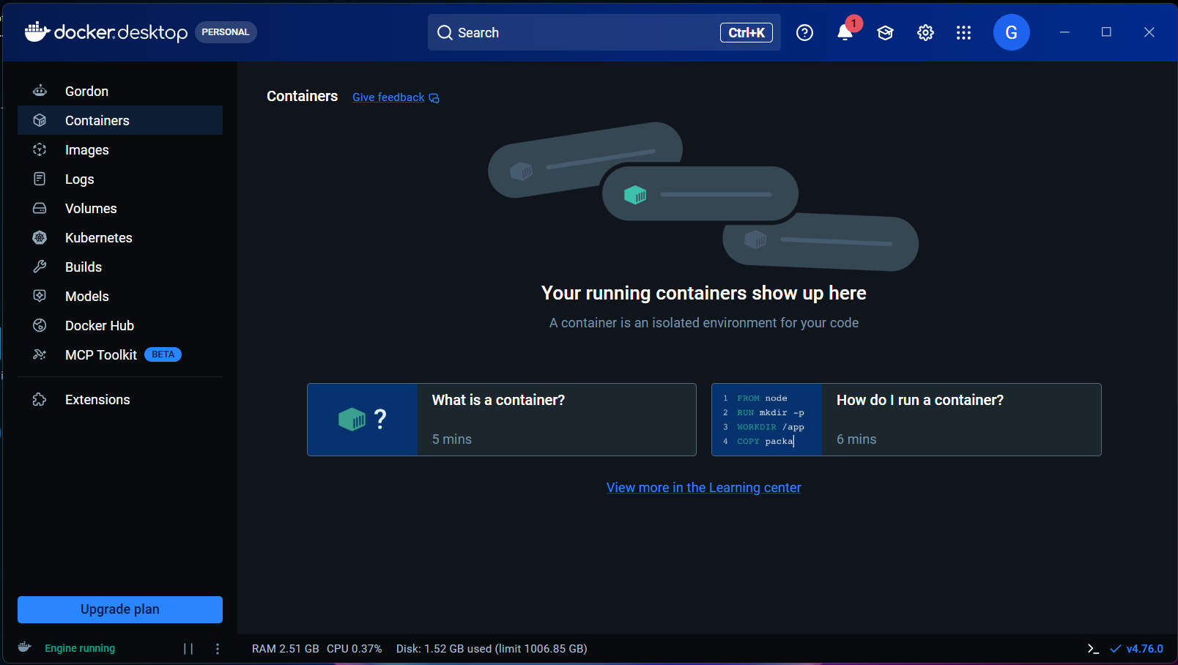

Setup minikube at locally:
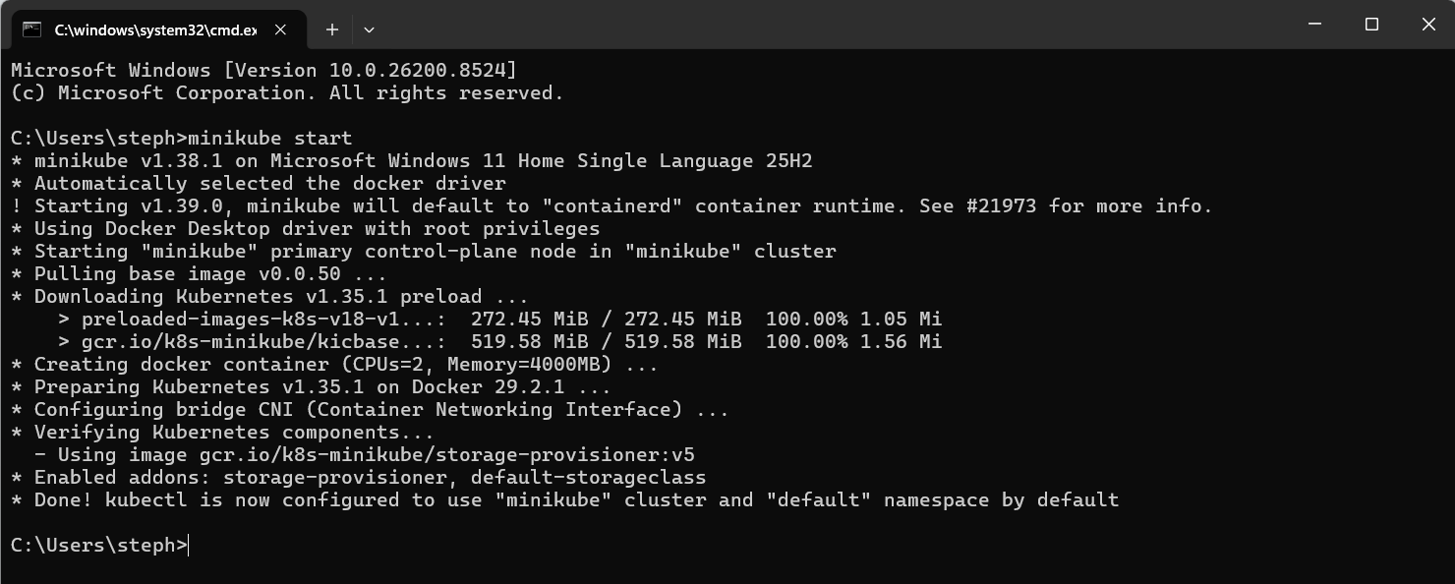
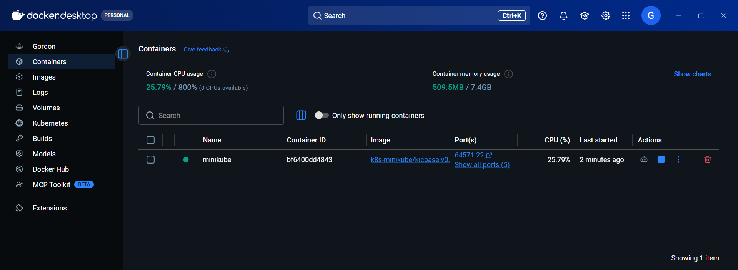
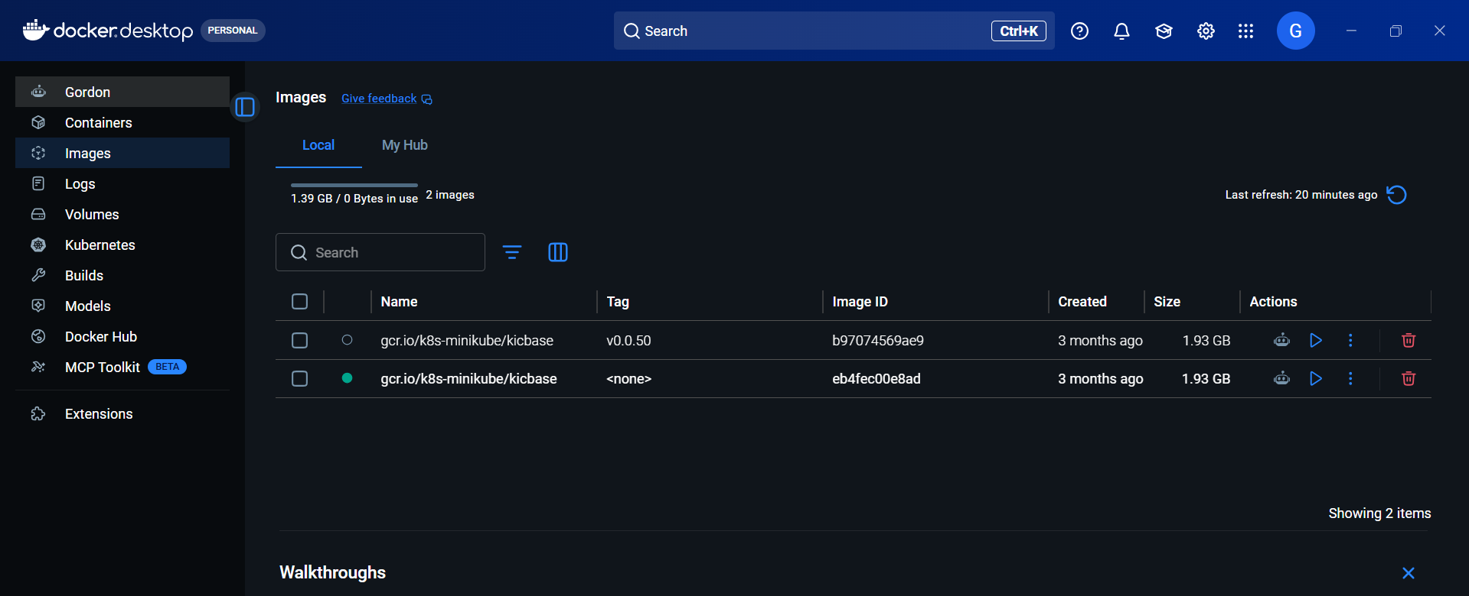
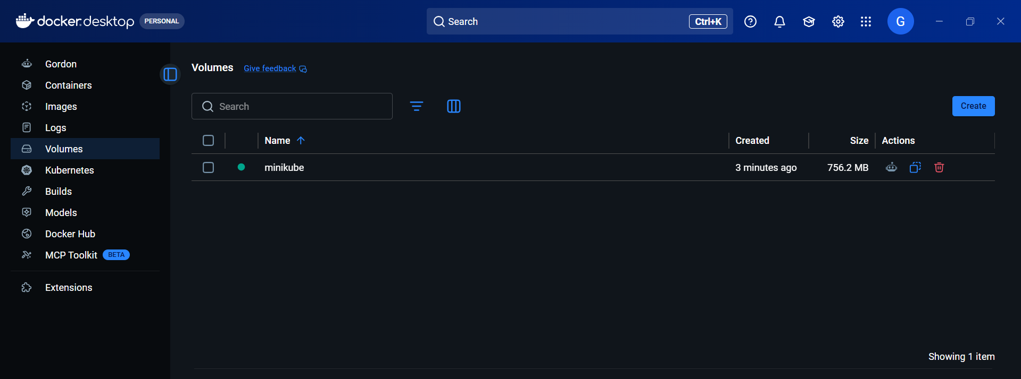

Install “kubectl tool” at local to proceeding further:
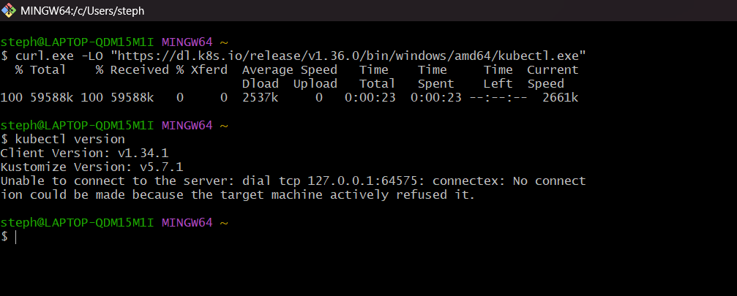

Minikube running as successfully:
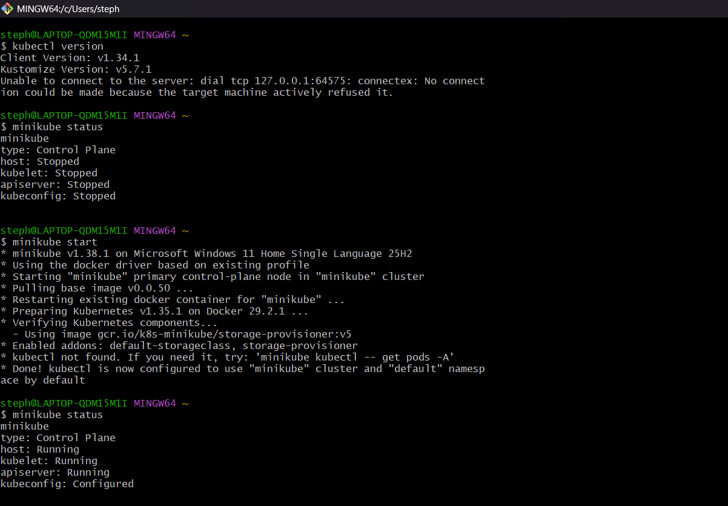

Delete pod and minikube:
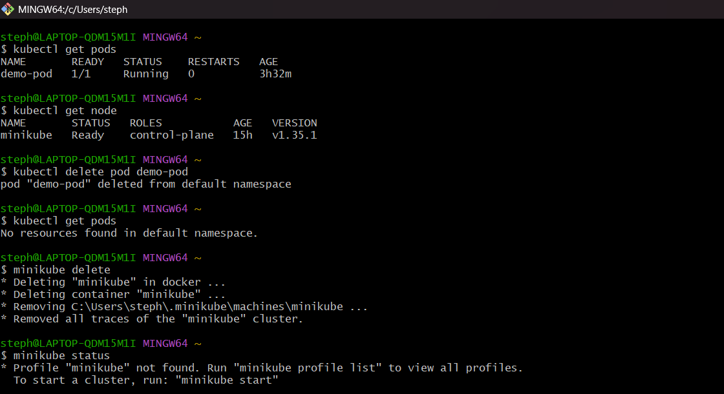

Creating namespaces in minikube:
Namespace created as “test-env”.
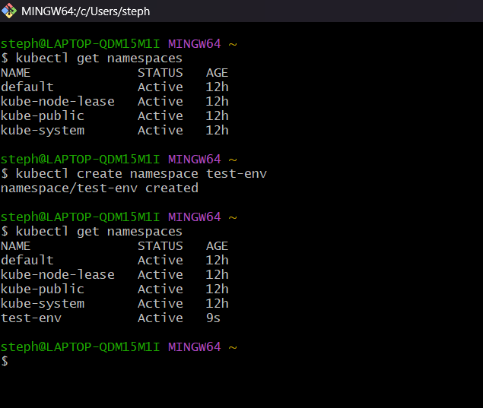
Deploy resources inside a new namespace:
Example: Create a pod in a namespace:
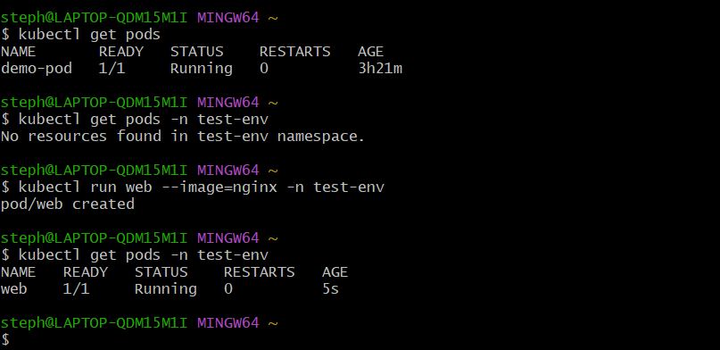

Delete a namespace:
